North Dakota District Lutheran Women In Mission 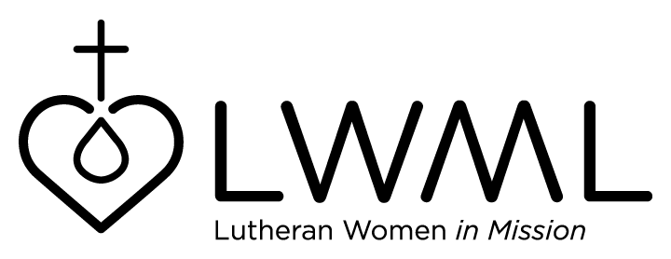
Candidate Resume Form
(Feel free to use additional page for more text)

Name:___________________________________________________________________________

Home Congregation: ________________________________Zone:_________________________

Address:_________________________________________________________________________

Telephone: Home & Cell:___________________________________________________________

Email:___________________________________________________________________________

LCMS Member since:______________________________________________________________

Offices/Committees (local cong):______________________________________________________

LWML – Unit:_____________________________________________________________________

LWML - Zone/District:______________________________________________________________

Community:______________________________________________________________________

Vocation:________________________________________________________________________

Education:_______________________________________________________________________

Personal Info (Family)__________________________________________________________________________

________________________________________________________________________________

Favorite Bible Verse:______________________________________________________________

What does LWML mean to me: ____________________________________________________

________________________________________________________________________________

________________________________________________________________________________
This serves as my consent to serve if elected to the North Dakota LWML Board of Directors:

Signed__________________________________________________Date___________________

RETURN TO: Kim Kuhlmann Cell: 701-320-0493
2402 N 4th St.
Bismarck, ND 58503 Email: k_kuhlmann@hotmail.com

